Coordinate System:

In geometry, coordinate system is a system which uses one or more numbers or coordinates to **uniquely determine the position of point.**

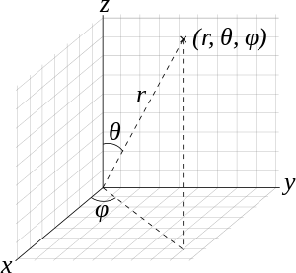

[spherical coordinate system](https://en.wikipedia.org/wiki/Spherical_coordinate_system)

Frame of Reference: <https://isaacphysics.org/concepts/cp_frame_reference>

***Physics Concept***

*Imagine you threw and caught a ball while you were on a train moving at a constant velocity past a station. To you, the ball appears to simply travel vertically up and then down under the influence of gravity.*

*However, to an observer stood on the station platform the ball would appear to travel in a parabola, with a constant horizontal component of velocity equal to the velocity of the train. This is illustrated in****Figure 1****below.*

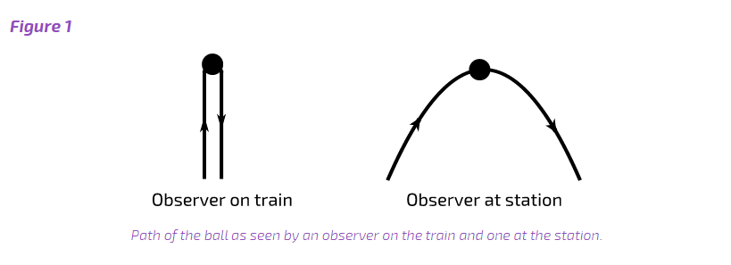

***The different observations occur*****because the two observers** *are in different****frames of reference****. (ONE OBSERVER IS IN REST AND ANOTHER IN MOTION).* ***A frame of reference*** *is a set of coordinates that* ***can be used*** *to determine positions and velocities of objects in that frame; different frames of reference move relative to one another.*

***Inertial frame of reference*** *is frame of reference in which body has* ***no net forc****e so it will* ***not*** *be accelerating i.e. such body will be at rest or will be moving in constant speed in a straight line. It is also called* **inertial reference frame**, **inertial frame**, **Galilean reference frame**, or **inertial space.**

**Newton’s inertial frame of reference:**

An inertial frame of reference is one in which the motion of a particle not subject to forces is in a straight line at constant speed.

**Non-inertial reference frame**: ***Non-inertial frames are accelerating frames.***

<http://zonalandeducation.com/mstm/physics/mechanics/framesOfReference/nonInertialFrame.html>

A **non-inertial reference frame** is a [frame of reference](https://en.wikipedia.org/wiki/Frame_of_reference) that is undergoing [acceleration](https://en.wikipedia.org/wiki/Acceleration) with respect to an [inertial frame](https://en.wikipedia.org/wiki/Inertial_frame_of_reference).

Detection of a non-inertial frame:

EXAMPLE:

1. ***A non-inertial frame of reference is a coordinate system which is accelerating.*** That is, its velocity vector is **not** constant. So, it is either **changing** its **speed** by speeding up or slowing down, or it is **changing** its **direction** by traveling in a curved path, or it is both changing its speed and changing its direction.

***The Elevator:***

Case1: **[1] Zero velocity at bottom:**

The elevator is **standing still** at the bottom of the shaft with a **constant velocity of zero**. The elevator is **not accelerating**.

Since its **velocity** is **constant**, the elevator at this moment is an **inertial frame of reference**. If you were in the elevator, you would feel your own weight as you would normally.

**[2] Increasing velocity upward:**

The elevator is moving upward and its **speed is getting greater and greater**. The elevator is **accelerating**.

Since its **velocity** is **not constant**, the elevator at this moment is a **non-inertial frame of reference**. If you were in the elevator, you would feel **more** than your normal weight. **You could imagine a fictitious force on you pulling you down and making you feel heavier.**

Actually, the floor of the elevator is pushing up on you in order to get you moving up along with the elevator.

1. ***Below is an animation of a rotating disk.*** Near the edge of the disk is an (x, y, z) coordinate system which is, of course, following a curved path. This coordinate system is moving in [circular motion](http://zonalandeducation.com/mstm/physics/mechanics/curvedMotion/circularMotion/circularMotion.html). The **speed** of the coordinate system is **constant**; however, it is **accelerating**.

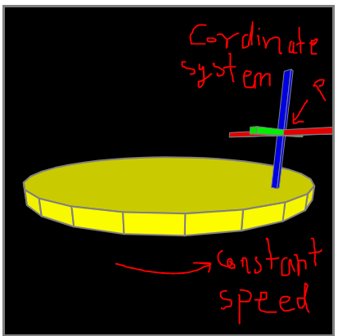

It is **accelerating** because its **velocity is changing**. Its velocity is changing because the **direction** of its movement is changing. Since velocity is made up of both speed and direction, when the direction changes, the velocity changes.

Since this coordinate system is **accelerating**, it is an example of a **non-inertial frame of reference**

***Since this is a non-inertial frame of reference, you should feel a fictitious force if you are using it as a reference.*** And you would. It would be especially noticeable if the disk were spinning quickly. You would feel pushed off of the disk. This force is often called the **centrifugal force**. It is a **fictitious force**. It really does not exist.

***There are several ways to describe a non-inertial frame. Here are a few descriptions:***

* A non-inertial frame of reference is a frame of reference with a changing velocity. The velocity of a frame will change if the frame speeds up, or slows down, or travels in a curved path.
* A non-inertial frame of reference is an accelerating frame of reference.
* A non-inertial frame of reference is a frame of reference in which the [law of inertia](http://zonalandeducation.com/mstm/physics/mechanics/forces/galileo/galileoInertia.html) does not hold.
* A non-inertial frame of reference is a frame of reference in which [Newton's laws of motion](http://zonalandeducation.com/mstm/physics/mechanics/forces/newton/newton.html) do not hold.
* In a non-inertial frame of reference fictitious forces arise.

***Such an accelerating frame of reference is called a non-inertial frame because the law of inertia does not hold in it.*** That is, an object whose position is judged from this frame will seem to spontaneously change its velocity with no apparent non-zero net force acting upon it. This completely violates the law of inertia and Newton's laws of motion, since these laws claim that the only way an object can change its velocity is if an actual non-zero net force is applied to the object. Objects just do not start to move about here and there all on their own.

***This is really quite easy to understand.*** If you are in an automobile when the brakes are abruptly applied, then you will feel pushed toward the front of the car. You may actually have to extend you arms to prevent yourself from going forward toward the dashboard. However, there is really no force pushing you forward. The car, since it is slowing down, is an accelerating, or non-inertial, frame of reference, and the law of inertia no longer holds if we use this non-inertial frame to judge your motion.

TO EXPALAIN THE MOTION OF BODIES IN THE NON-INERTIAL REFERENCE FRAME, FICTIOUS FORCE MUST BE INTRODUCED TO ACCOUNT FOR THE OBSERVED MOTION.

E.G. IN ROTATING FRAME OF REFERENCE, THE BODY AT REST WILL EXPERINCE CENTRIFUGAL FORCE WHICH IS FICTIOUS FORCE.